# Lab 2 Report

## Ruijie Song

## Feb.04.2021

Section 1 Report:

1.



Figure 1. The gray scale image img04g.tif.

2.

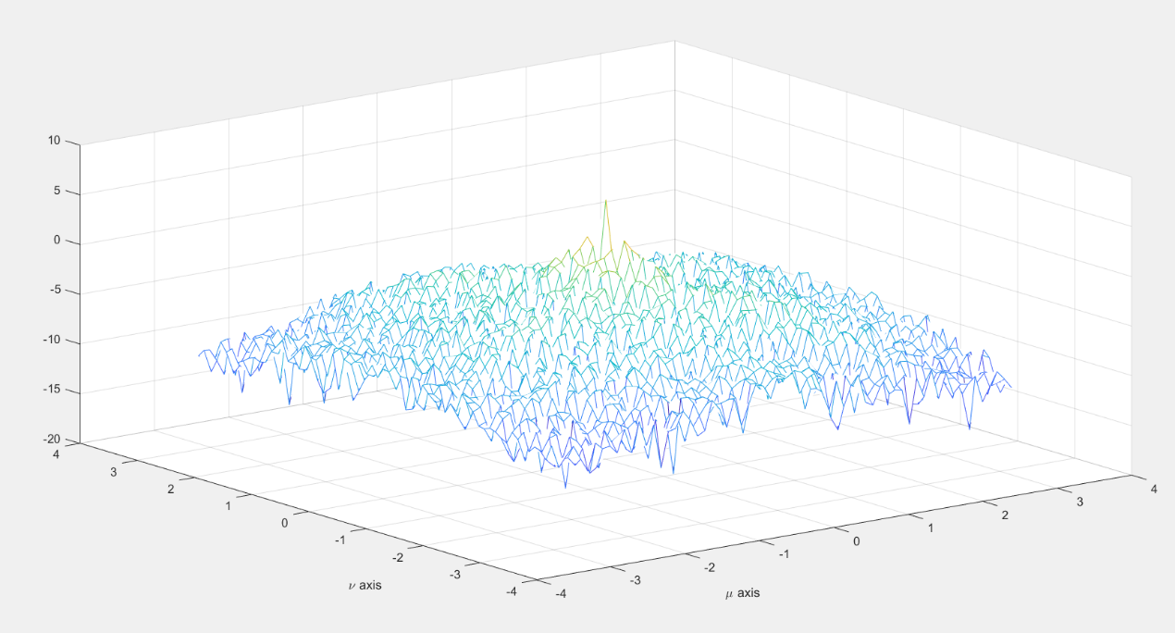

Figure 2. The power spectral density plots for block sizes of 64 × 64

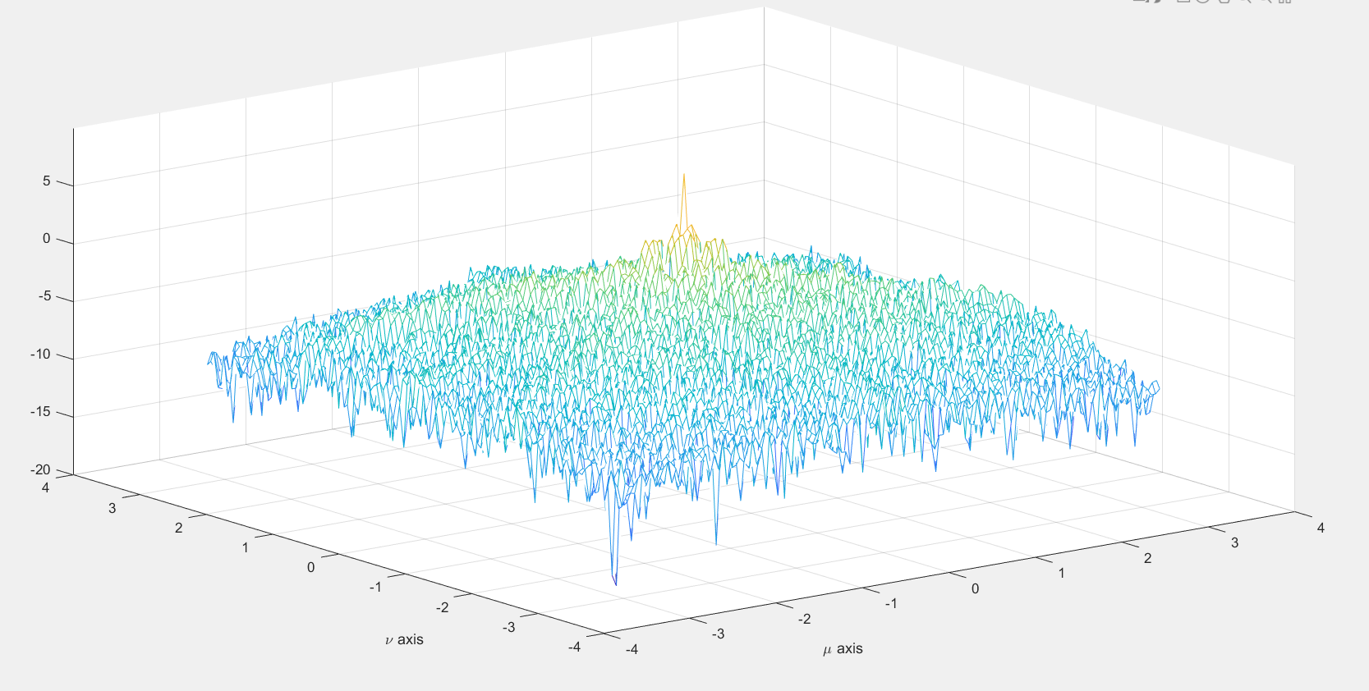

Figure 3. The power spectral density plots for block sizes of 128 × 128

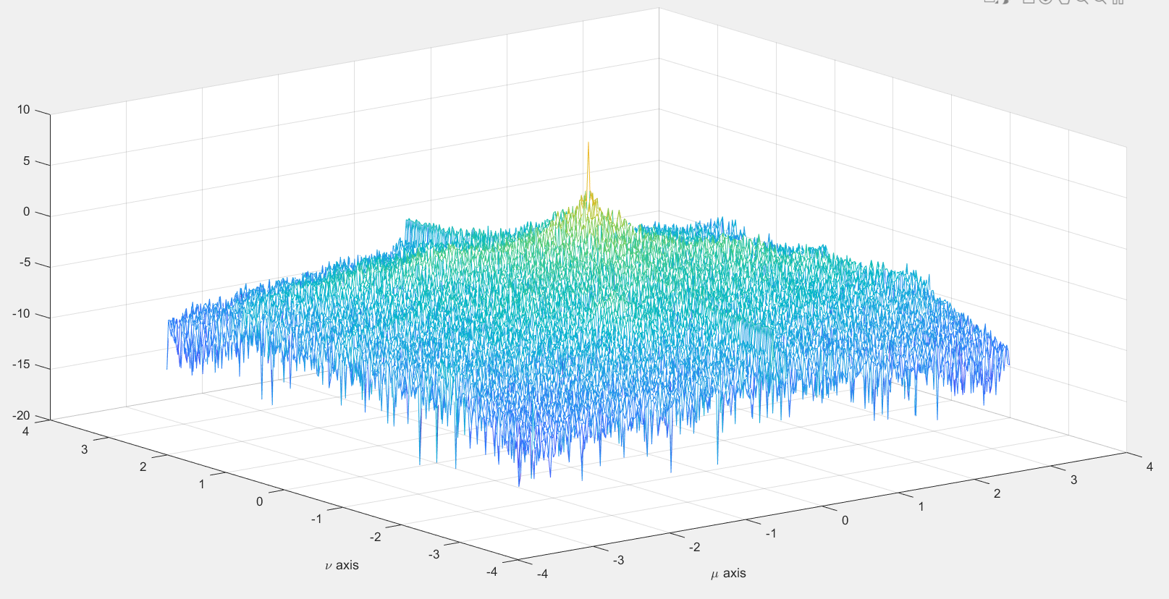

Figure 4. The power spectral density plots for block sizes of 256 × 256

3.

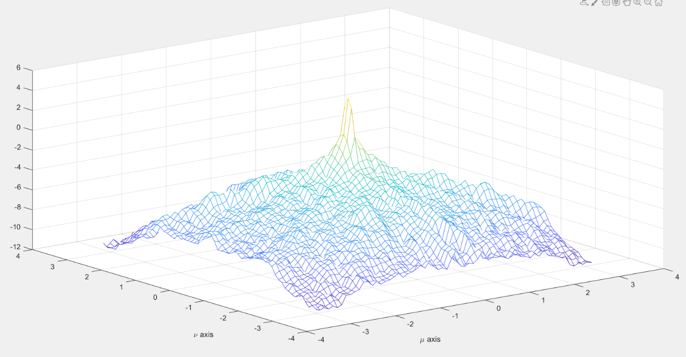

Figure 5. The improved power spectral density estimate.

2 Power Spectral Density of a 2-D AR Process

1.

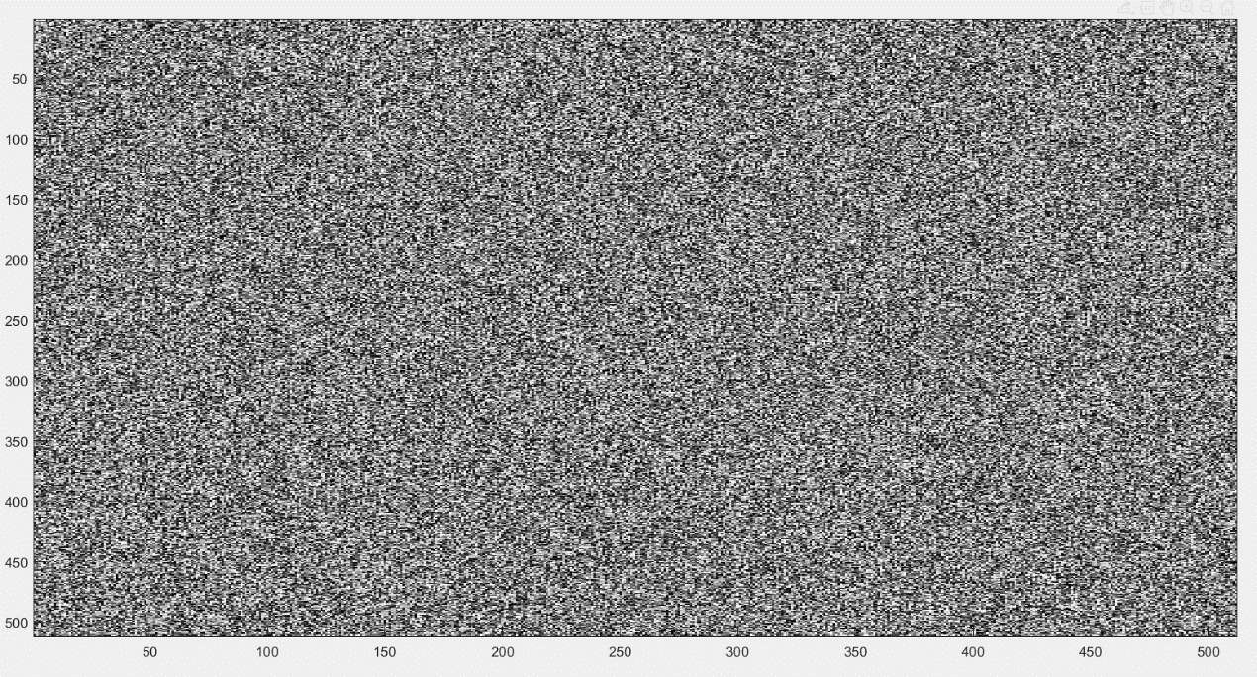

Figure 6. The image 255 ∗ (x + 0.5).

2.

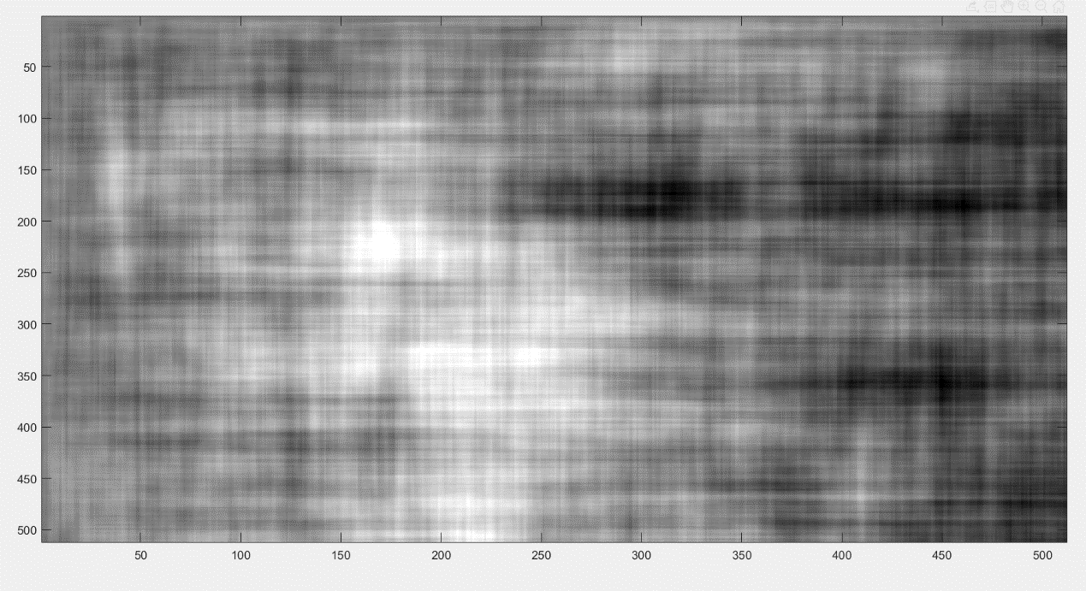

Figure 7. The image y + 127.

3.

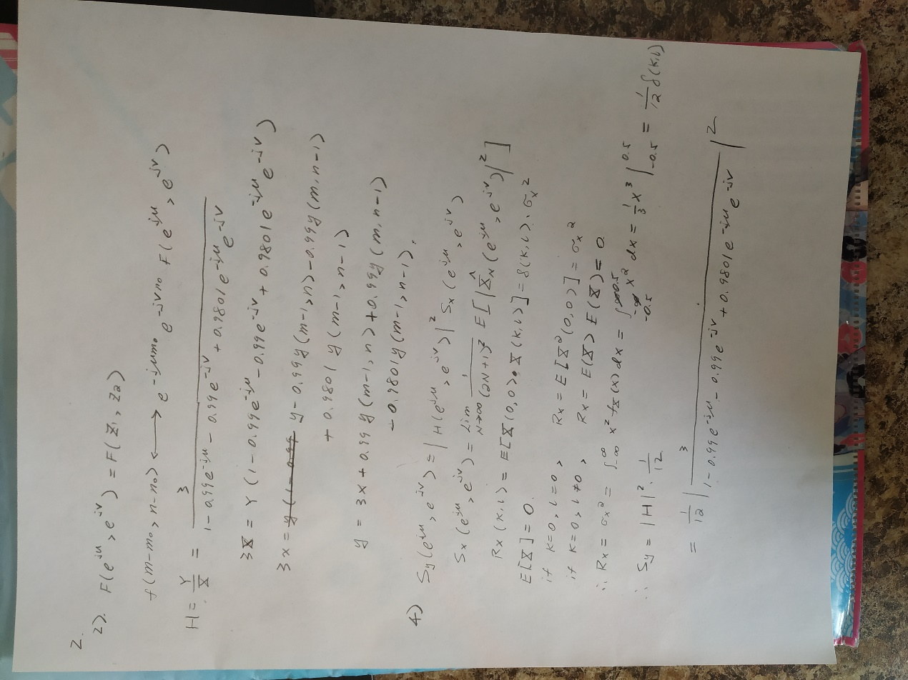

Figure 8. Theoretically calculate Sy

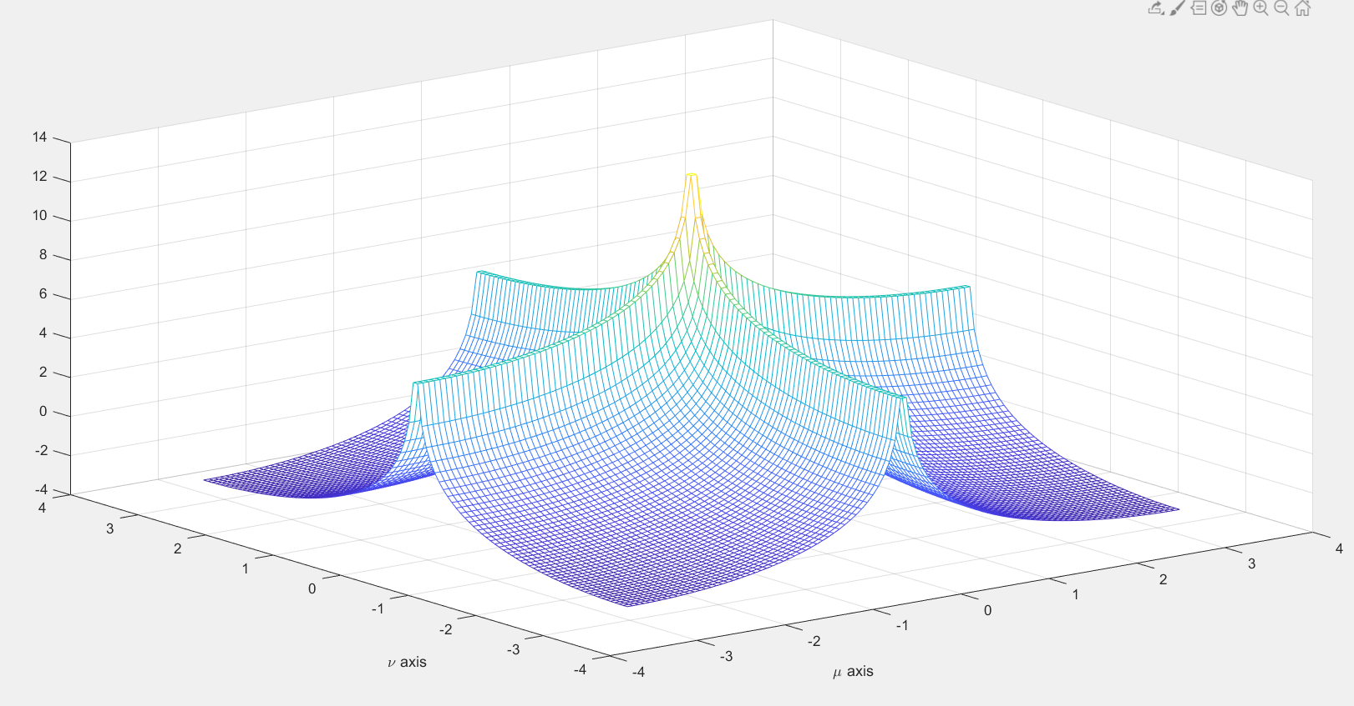

Figure 9. A mesh plot of the function log Sy

4.

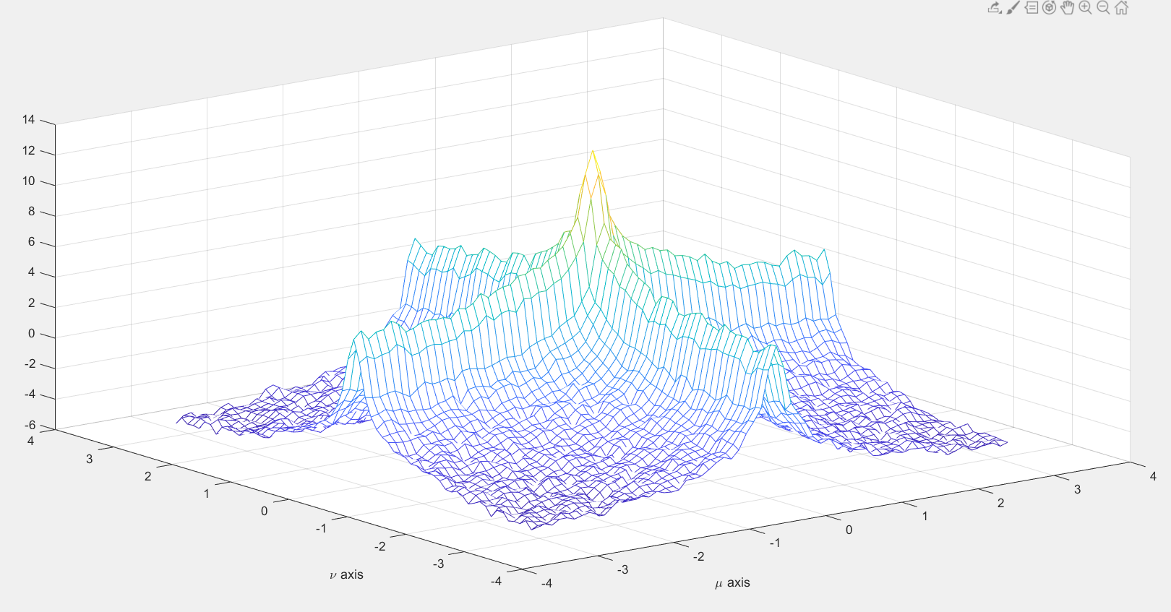

Figure 10. A mesh plot of the log of the estimated power spectral density of y using BetterSpecAnal(y)